Algebra 2 Name: _______________________ Period: ________
Unit 2A Test

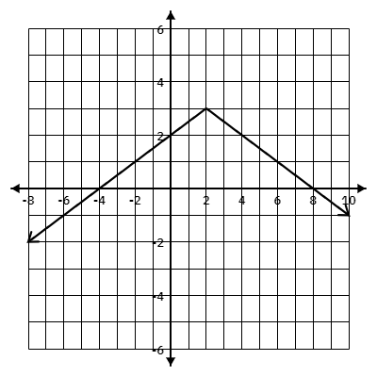
Using the graph provided answer the questions 1-9:
1. The domain of the function is:
A. $(-∞, 3]$ B. $(-∞, ∞)$
C. $(-∞, 3)$ D. $(3, ∞)$
2. The range of the function is:
A. $(-∞, 3]$ B. $(-∞, ∞)$
C. $(-∞, 3)$ D. $(3, ∞)$
3. The function has a minimum at $(2, 3).$
A. True B. False
4. The vertex of the function is:
A. $(-4,0)$ B. $(8,0)$ C. $(0, 2)$ D. $(2, 3)$
5. The x-intercepts are (circle all that apply):
A. $(-4,0)$ B.$(0, 2)$ C. $(8,0)$ D. $(2, 3)$
6. The y-intercept is:
A. $(-4,0)$ B. $(8,0)$ C. $(0, 2)$ D. $(2, 3)$
7. The equation of the function is:
A. $f(x)=-2\left|x-2\right|+3$ B. $f(x)=-2\left|x+2\right|+3$
C. $f(x)=-\frac{1}{2}\left|x-2\right|+3$ D. $f(x)=-\frac{1}{2}\left|x+2\right|-3$
8. The axis of symmetry is:
A. $y=2$ B. $y=3$ C. $x=2$ D. $x=3$
9. The verbal description is:
A. Reflect over y-axis, Shift down 3, Shift Right 2, Vertical Stretch by 2.
B. Reflect over x-axis, Shift down 3, Shift Right 2, Vertical compression by $\frac{1}{2}$.
C. Reflect over y-axis, Shift up 3, Shift left 2, Vertical Stretch by $\frac{1}{2}$.
D. Reflect over x-axis, Shift up 3, Shift Right 2, Vertical compression by $\frac{1}{2}$.
Using the equation provided answer the questions 10-17:
$f(x)=\left|x-9\right|-4$
10. The function notation description is:
A. $f(x-9-4)$ B. $f(x)-9-4$
C. $f(x-9)-4$ D. $f(x)=\left|x-9\right|-4$
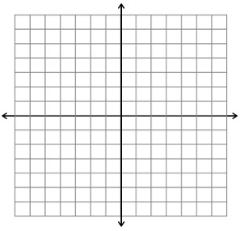
11. Provide the verbal description of this function.________________________________________________
12. Graph this function on your answer sheet in the grid to the right.
13. The vertex of the function is:
A. $(-4,9)$ B. $(9,-4)$ C. $(0, 5)$ D. $(5,0)$
14. The domain of the function is:
A. $(9,∞)$ B. $[5, ∞)$ C. $(-∞, ∞)$ D. $[-4, ∞)$
15. The range of the function is:
A. $(9,∞)$ B. $[5, ∞)$ C. $(-∞, ∞)$ D. $[-4, ∞)$
16. This function has a minimum of (9, -4).
A. True B. False
17. Provide the axis of symmetry.______________________

Given a description of a function, choose the correct equation.
18. A function is reflected over the x-axis, stretched vertically by 3, shifted right 2 units and down 4 units, choose the correct equation:
A. $f(x)=-\frac{1}{3}\left|x+2\right|-4$ B. $f(x)=-3\left|x+2\right|-4$
C. $f(x)=-\frac{1}{3}\left|x-2\right|-4$ D. $f(x)=-3\left|x-2\right|-4$
19. A function is compressed vertically by $\frac{1}{4}$, shifted left 4 units and up 7 units.
A. $f(x)=4\left|x+7\right|-4$ B. $f(x)=4\left|x-4\right|-7$
C. $f(x)=4\left|x+4\right|+7$ D. $f(x)=\frac{1}{4}\left|x+4\right|+7$

